25.72: a) With a voltmeter in the circuit:
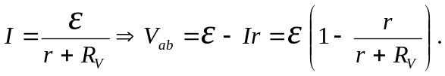
b) We want:
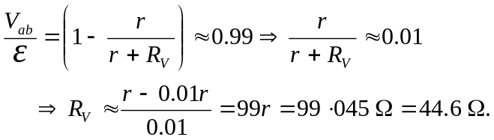
c) This is the minimum resistance necessary—any greater resistance leads to less current flow and hence less potential loss over the battery’s internal resistance.

